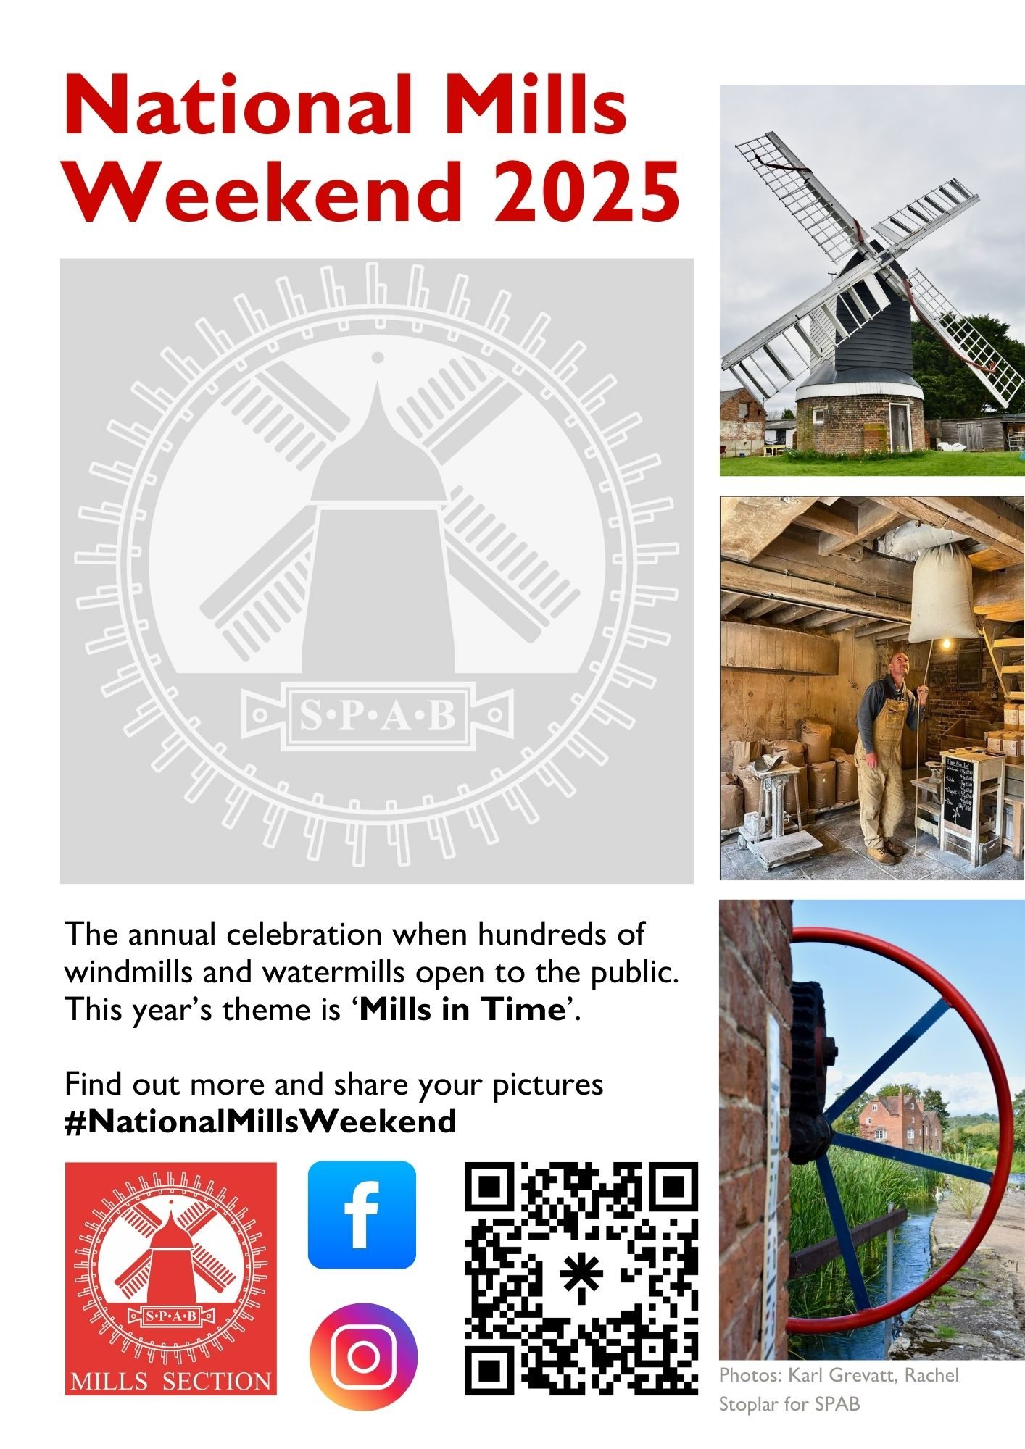
Saturday 10 & Sunday 11 May
Kibworth Harcourt Post Mill, Leicestershire LE8 0PR
Open 10am-4pm, free

