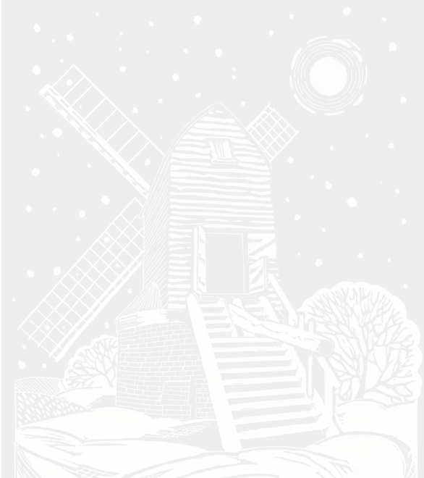
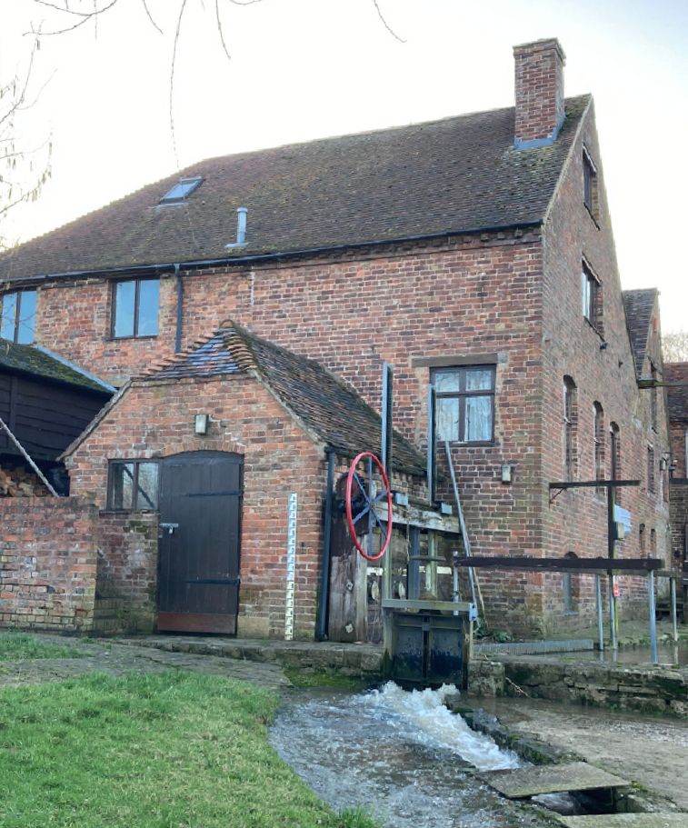
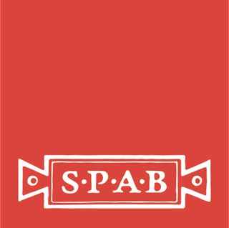
National Mills Weekend
Saturday 9 & Sunday 10 May 2026

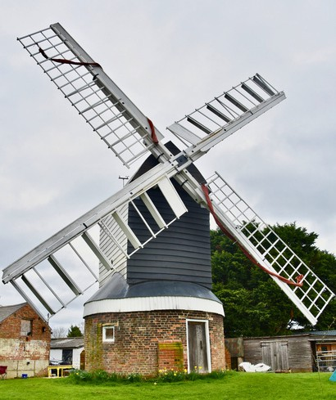

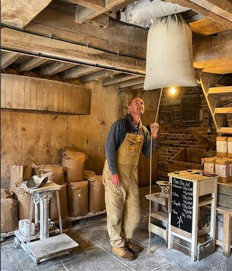

An annual celebration when hundreds of mills open to the public.
This year’s theme is Mills: Now and Then.
Find out more and share your pictures #NationalMillsWeekend

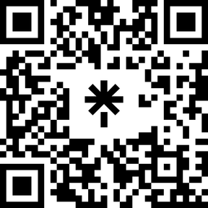
Illustration © Penny Streeter. Photos © Karl Grevatt, Rachel Stoplar for SPAB

